* ReactJS is JavaScript collection used for building reusable UI components. Description can be initiate on React official documentation −
  + React is a library for building composable user interfaces.
  + It encourages the creation of reusable UI components which present data that changes over time. Lots of people use React as the V in MVC.
  + React extracts away the DOM from you, giving a simpler programming model and better performance.
  + React can also render on the server using Node, and it can power native apps using React Native.
  + React implements one-way reactive data flow which reduces boilerplate and is easier to reason about than traditional data binding.

**How React works**

**Real Time Data**

**User Input**

**Initial Data**

**Dispatcher**

**View**

**Store**

**REACT Environment Setup:**

1. Download and install node.js in your pc

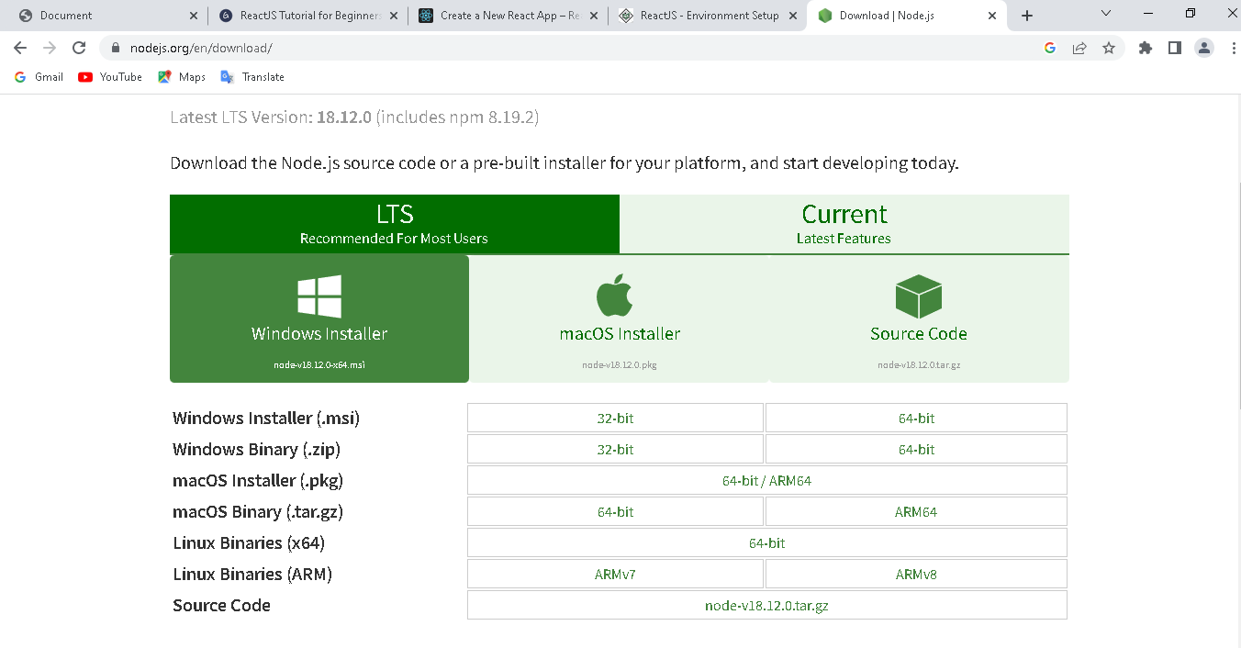

1. Open cmd prompt and choose your path

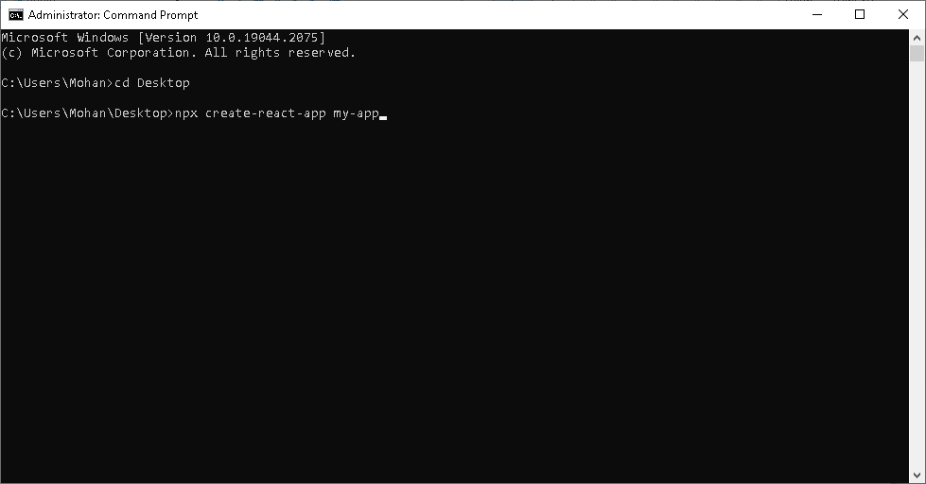

1. After creating my-app , cd/my-app. And npm start

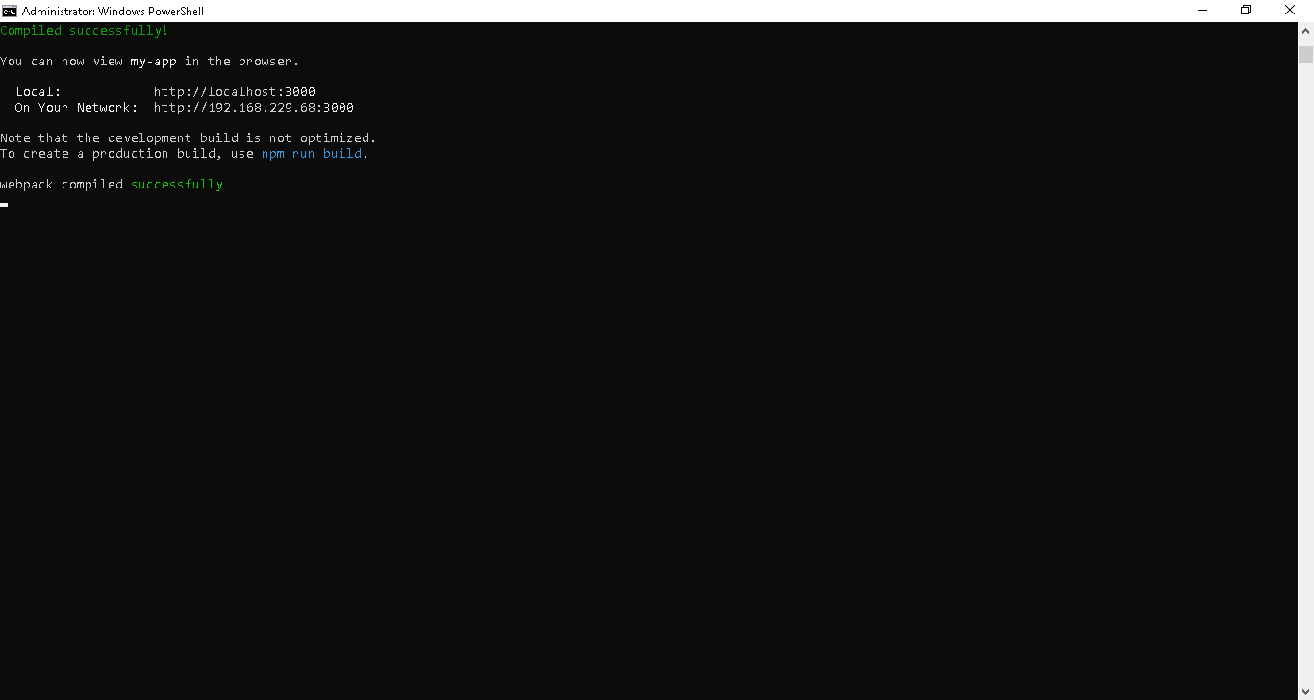

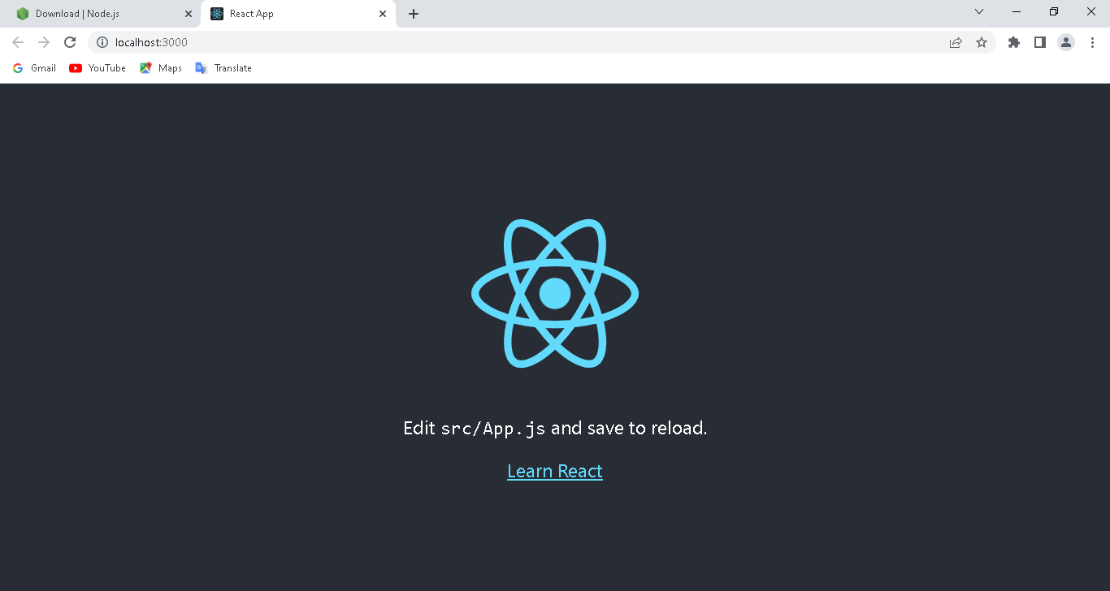

Priting HEllO WORLD in reactjs with integrated terminal

